

Portfolio Project

CodeX Energy Drink Survey Analysis



**MuhammaD Saad**

**Cohort: Red**

**Atom Camp Data Science Bootcamp**

# CodeX India Market Survey Analysis Report

## Executive Summary

CodeX, a German beverage company, launched its energy drink in 10 cities in India a few months ago. This report presents the findings and recommendations based on a survey conducted in those cities, with responses from 10,000 respondents. The survey aims to provide insights for the Marketing team to increase brand awareness, market share, and product development in the Indian market.

Table of Contents

CodeX India Market Survey Analysis Report 0

Executive Summary 1

1) Introduction 2

2) Data Description 2

2.1) Respondents 2

2.2) Cities 2

2.3) Survey Questions 2

3) Data Cleaning, Preprocessing, and Methodology 3

3.1) Assumption for average daily consumption 3

4) Primary & Secondary Insights 4

4.1) Demographic Insights 4

4.2) Consumer Preferences 5

4.3) Competition Analysis 6

4.4) Marketing Channels and Brand Awareness 7

4.5) Brand Penetration 8

4.6) Purchase Behavior 9

4.7) Product Development 11

5) Recommendations 13

6.1) Ideal Price: 13

6.2) Immediate Improvements: 13

6.3) Marketing Campaigns, Offers and Discounts 13

6) Conclusion 14

## Introduction

This report will provide the reader with necessary information regarding the Primary and Secondary insights of the survey conducted in 10 cities of India covering 10,000 respondents, which will be discussed later. These insights will revolve around the factors affecting the business e.g., brand analysis, its market penetration, consumer trends, location wise brand awareness, competition, pricing comparison and general perception.

As a marketing data analyst, I have included the recommendations and suggestions at the end of the report.

## Data Description

There are three Data Sets from the survey.

* 1. Data of the survey respondents.
  2. Data of the cities from where respondent are based in.
  3. Data of the Answers to the questions comprised in the Survey.

### Respondents

This Data set comprises of Respondent-ID, Respondent’s Name, Respondent’s Age, Respondent’s Gender, and Respondent’s City-ID of the respondents.

### Cities

This Data set comprises the information regarding City-ID, and City Name.

The survey was conducted in 10 Indian cities.

* Delhi
* Mumbai
* Bangalore
* Chennai
* Kolkata
* Hyderabad
* Ahmedabad
* Pune
* Jaipur
* Lucknow

### Survey Questions

This Data set comprises of multiple survey questions about the brand CodeX, its awareness, consumption habits, favorite brands (other brands also), rating, ingredients etc. Many more will be discussed in the Primary and Secondary insights.

## Data Cleaning, Preprocessing, and Methodology

Two methods were applied for the sake of easiness. First, for the individual analysis, **Xlookup** command was used in **excel** to merge the data of three data sets into one. Secondly, for visualization ease, **PowerBI** is used to create the connections in Model, so that seamless association is established between the three data sets.

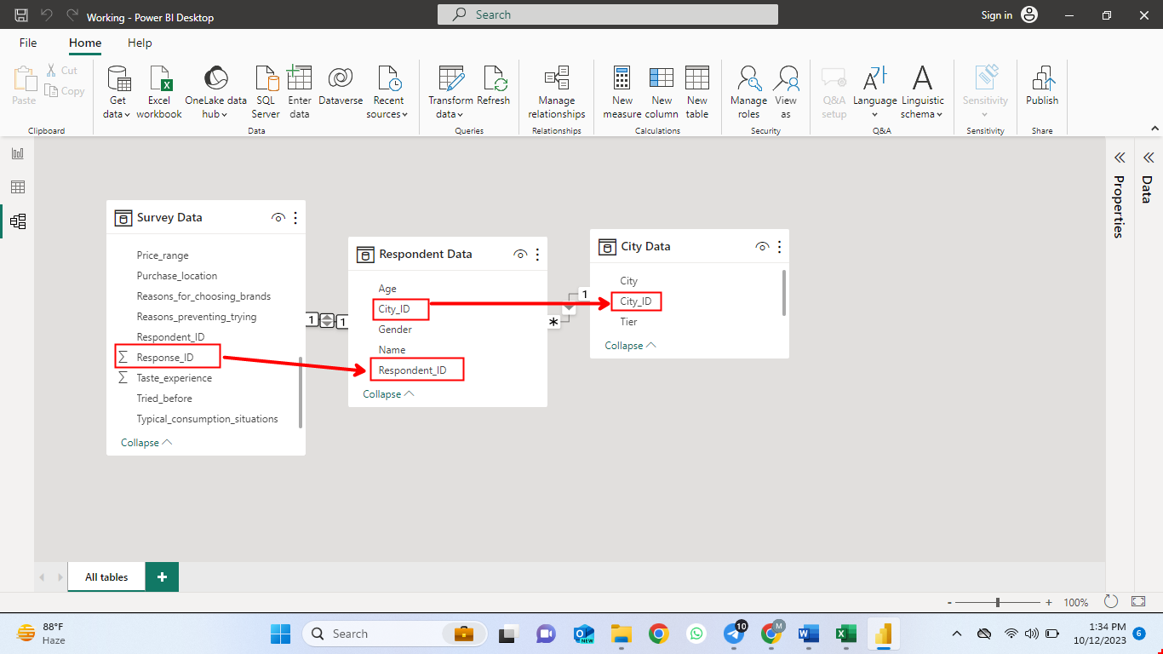

3.1: Connection Schematic (Power BI)

After importing the data in Power Query, connections were automatically detected by the Model Pane as shown in Figure 4.1. Primary and Secondary Insights were drawn using different visualization methods best suited for the type of analysis. Also, there must be numerical gauge for the consumption rather than categorical, so average daily consumption was calculated by adding a conditional column.

### Assumption for average daily consumption

To calculate the average daily unit consumption, assumption was given as per the table below:

|  |  |
| --- | --- |
| Consumption Frequency | Assumption |
| 2-3 times a week | = 2.5/7 |
| 2-3 times a month | = 2.5/30 |
| Daily | = 1 |
| Once a week | = 1/7 |
| Rarely | Once a month (=1/30) |

## Primary & Secondary Insights

### Demographic Insights

#### Energy Drink Preference by Gender:

There were two issues faced while checking which gender prefers the energy drink most.

1. Non-Equal Sample size of all genders. Sample size of male responders ( is much greater than that of the others i.e., female, and non-binary.

4.1: Respondents total by gender

1. Non-Numeric Consumption gauge. The categorical options for consumption frequency doesn’t allow to calculate the actual consumption by gender. So, a variable average daily consumption is introduced.

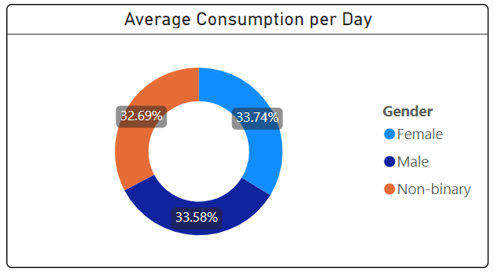

4.2: Daily Average Consumption by Gender

The results in the above figure show that Female Gender prefers the energy drinks more than the others. However, the difference is very less but still females prefer energy drink more.

#### Energy Drink Preference by Age Group:

Similarly, the people with age lying under the range of **31-45** prefer energy drinks more than the other people. This means that energy drink is more popular in mature age people (30s to mid-40s)

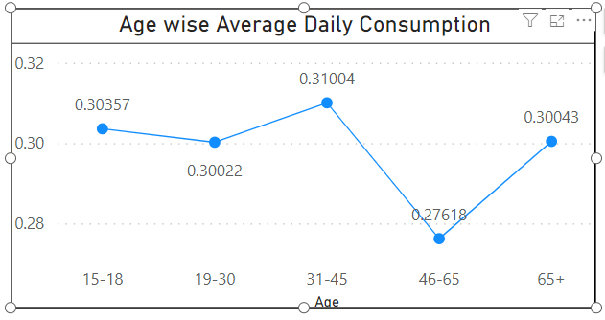



4.3: Age wise Average Daily Consumption

#### Marketing Strategy among Youth (15-30)

Filtering the Age Groups **15-18** and **19-30**, shows that **48%** of the youth is attracted by the Online ads and **25%** of youth is attracted by TV Commercials. A total of **73%** of youth reached by the ads and commercials. This also clearly shows that conventional marketing strategies don’t have that much of the impact caused by digital and TV advertising.

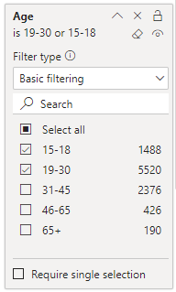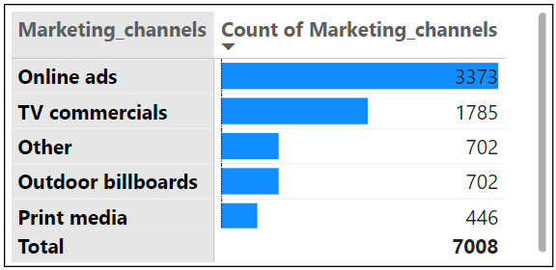

4.4: Marketing Penetration among Youth

### Consumer Preferences

#### Preferred Ingredient of Energy Drink

**39%** of the people drink energy drinks for caffeine purposes. The second most wanted ingredient is guarana. Guarana itself contains high contents of caffeine, so boosting the energy levels is the main purpose of energy drinks which is also well depicted by the data analysis as per picture attached.

4.5: Preferred Ingredients Break-up

#### Packaging Preference:

Most of the people prefer Compact and Portable cans for the packaging of energy drinks. The second most preferred packaging is Innovative Bottle Design. This data shows the importance of packaging. For instance, Tetra Pak has been investing millions of fortunes in R&D and is delivering innovative solutions to packaging, which means that part of consumer preference is also based on the type of packaging brands are using.

4.6: Tally of Packaging liked by the responders

### Competition Analysis

#### Market Leaders

Since we do not have the business financial variables like revenue, profit, price, sales etc., the market leading energy drink brand will only be found based on consumer preference i.e., which brand they currently consume.

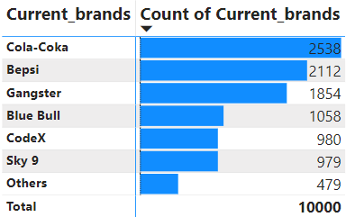

4.7: Current Market Leaders

Above Figure shows that Cola-Coka and Bepsi are the market leaders holding a **47%** consumer preference market share of total brands. **Code X** lies in the last, not considering **others** as a brand.

#### Primary Reason for Other Brand Preference

Filtering the brands other than CodeX and making the visualization of the primary reasons of consumers choosing other brands show that the main reason is Brand reputation.

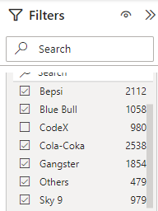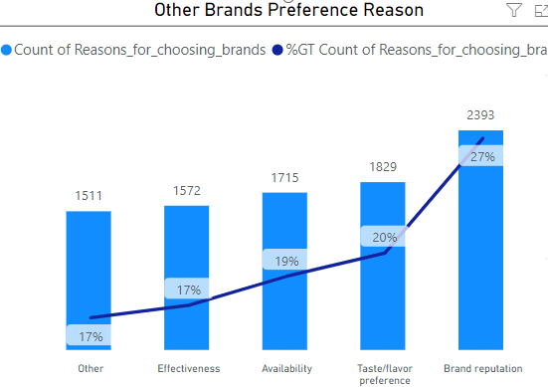

4.8: Reasons affecting the Preference.

### Marketing Channels and Brand Awareness

#### Effective Marketing Channel for Other Brands

Brands other than CodeX have used online ads and TV commercials as a medium to market the brand among the consumers. 40% responders get awareness through Digital Media and 27% responders get awareness through TV Commercials. Other conventional marketing channels aren’t that effective.

4.9: Marketing Channels for other Brands

#### Effective Marketing Channel for CodeX

After filtering the data of Code-X (980), it is observed that 42% of the total CodeX users are being affected by the online ads and 27% of them have heard about the brand through TV commercials. Remaining heard of CodeX from other marketing channels. So Digital Marketing and TV Commercial are the most effective.

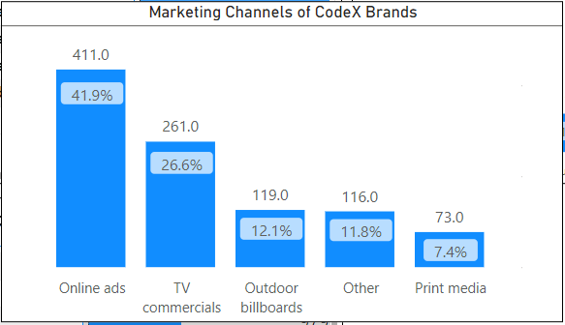

4.10: Marketing Channels of CodeX

### Brand Penetration

#### CodeX overall Rating

To check what do people think about CodeX, a variable rating was used in the survey to gauge the inclination towards the Brand. There are many respondents who haven’t tried CodeX before, so they are not included for this analysis.

4.11: Overall Rating of CodeX

There are 5 ratings from 1-5, with 1 being Poor and 5 being Excellent. The Average rating suggests that consumer experience lies in between 3 (Average) and 4 (Good). So Overall Experience is satisfactory but there should be improvement in taste so that it can be approaching good or excellent.

#### Cities to be Focused More

To check which cities must be focused more, those respondents must be figured out who don’t have the knowledge regarding the brand presence. Stats of response show that out of 10,000 responders only 44% have heard about the brand, the remaining (56%) haven’t.

Since survey is conducted in 10 big cities of India, it was expected that number of responders participating will be equal from each city.

From Bird’s Eye View, it appears that the highest number of respondents who haven’t heard of Brand CodeX reside in **Bangalore**.

4.12: City wise responders not familiar with CodeX

But diving deep into the data, the proportion of respondents in each city unfamiliar with brand are as in the figure below.

|  |  |  |
| --- | --- | --- |
| City | ***No*** | ***Yes*** |
| Kolkata | 62.90% | 37.10% |
| Chennai | 60.30% | 39.70% |
| Hyderabad | 60.28% | 39.72% |
| Jaipur | 60.00% | 40.00% |
| Bangalore | 59.05% | 40.95% |
| Pune | 58.39% | 41.61% |
| Ahmedabad | 54.61% | 45.39% |
| Lucknow | 51.43% | 48.57% |
| Mumbai | 40.46% | 59.54% |
| Delhi | 37.76% | 62.24% |

4.13: Proportion of Unfamiliar responders (City wise)

Overall, every city needs to be focused more rigorously. To name a few Kolkata, Chennai, Hyderabad, and Jaipur need more focus.

### Purchase Behavior

#### Preferred Location for Purchase

The Graph below shoes that most of the people (45%) prefer Supermarkets to buy the energy drinks.

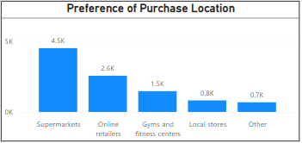

4.14: Preferred Source of Energy Drinks purchase

#### Purchase Situations

Most of the people purchase energy drinks to boost their energy levels when they are doing sports or hitting the gym i.e., **45%** as depicted by the figure below.

4.15: Preferred Purchase situation

#### Factors Influence Respondents' Purchase Decisions

There are multiple factors which affect purchase decisions. Let’s check one by one!

* Price Range do affect the purchase decision. Ideally the lower the price, the more is the consumer tended to purchase, provided the quality is not compromised and rigorous branding is done.

4.16: Price Range Comparison with Average Daily Consumption among 10,000 responders

* Limited Edition Packaging factor doesn’t affect the purchase decision as the figures show that almost an equal number of responders answered yes and not this specific question. Furthermore chi-squared analysis also suggested that the correlation model of this variable is not significant.

4.17: Limited Packaging Edition

* The availability of Energy drinks also affects the purchase decision. 12% of the responders haven’t tried CodeX because it’s not available locally.

4.18: Availability of Energy Drinks

* Brand Reputation and Flavors are also affecting factors for purchase decisions. Almost 47% of the respondents have responded that they choose brands due to their reputation or taste. This means that Code X should work both on Brand Marketing and Quality.

### Product Development

To check which areas CodeX must focus more on, Data must be analyzed based on Branding, taste, and availability. One-by-one analysis is as follows:

1. The average rating of CodeX tase experience is 3.27 which falls between Average and good.

4.19: Taste Experience Analysis

This rating is acceptable.

1. If we see the availability of CodeX from the data collected from Survey, we can observe that out of 5119 responders who haven’t tried the energy drink, 1165 people say that this is not available locally.

4.20: Availability Analysis

There is a high chance that people who have responded “not available locally” might have missed every time they go the shops or supermarkets. Ideally, every business first makes the product available locally then conducts the survey.

1. If we see the current branding scenario of CodeX from survey data, out of 5553 responders who haven’t heard of CodeX, 967 of people are unfamiliar with the brand.

4.21: Branding Analysis

There is no specific answer to choose from the above analyses. Considering the claim of responders regarding availability of energy drink, brand should work more closely with making the product available locally. If we reject the hypothesis, CodeX company should focus more on branding, making everyone familiar with the product.

## Recommendations

Based on the primary and secondary insights, provide actionable recommendations for the Marketing team.

### Ideal Price:

Someone would say that the ideal price will be as low as possible. But that shouldn’t be at the expense of compromising the quality and branding. Most of the people prefer the price range of INR 50-99. Hence, according to my analysis, INR 70 is a good price which complies with both public demand and the company’s interest.

### Immediate Improvements:

Ther are number of improvements CodeX can implement such as:

* Increase awareness through targeted marketing campaigns. Target the mature aged people in terms of online ads as the analysis showed that people aged **30** to **45** years consume energy drinks more than the others.
* To make the average rating even better, improve taste perception through flavor enhancements and reducing sugar contents because **30%** of the people expect less sugar and **25%** of the people expect that energy drinks must have natural ingredients. This can prove to be a converting point for those who don’t consume energy drinks. Through better taste and healthy natural ingredients retention ration can be increased.
* Most of the consumers **(45%)** purchase energy drinks to back their energy levels up to do physical exercise. Also, **36%** of the consumers consume energy drinks to increase energy and focus. It indicates that proper availability of Code X at gyms and sports arenas can easily penetrate among consumers and will be a good way to make brand presence assured.

### Marketing Campaigns, Offers and Discounts

#### Influential Marketing

Most important marketing strategy these days is pitching the brand awareness through influencers. Famous Fitness Models, Dietitians, and local celebrities can be used for influential marketing which will help Code-X in promoting the awareness of brand and penetration among consumers.

#### Social Media Marketing

Above influential marketing strategy can be blended with Social Media platforms to foster the engagement of audience to turn them into regular consumers.

#### Sponsorships and Collaborations

Partnering with local sports platforms and Gym communities can also be a beneficial tool for marketing.

#### First-Buyer Discounts

An introductory discounted campaign can be introduced to first buyers for a limited period of time in supermarkets and shops.

#### Seasonal Promotion

Summer season is a good period of year for pitching the idea regarding energy drinks and discounted promotion can be made via social media marketing.

#### Bundled Packages

Introducing a bundle package, say save INR 50 on a pack of 6, could be a good move for increasing the sales.

## Conclusion

Concludingly, the main key factors behind the growth of any brand are availability of products locally, sufficient brand presence among stores and targeted social media campaigns which has been discussed in detail before.